**Online Room Reservation and Room Management   
(IT18149654 – Rajapaksha T.N.)**

Under this function there were three main responsibilities.

1. Designing and creating the official website for the Peter’s Place Hotel
2. Enabling customers to make reservations online (book hotel rooms from home)
3. Enabling the room manager of the hotel to manage hotel rooms, room types and room reservations.

The designed official website for Peter’s Place Hotel is an attractive website which is also responsive and user-friendly.

It was built using HTML, CSS, Bootstrap, JavaScript and jQuery.

Anyone can view this website without needing any login and if necessary, they can make online room reservations by providing their personal and reservation information.

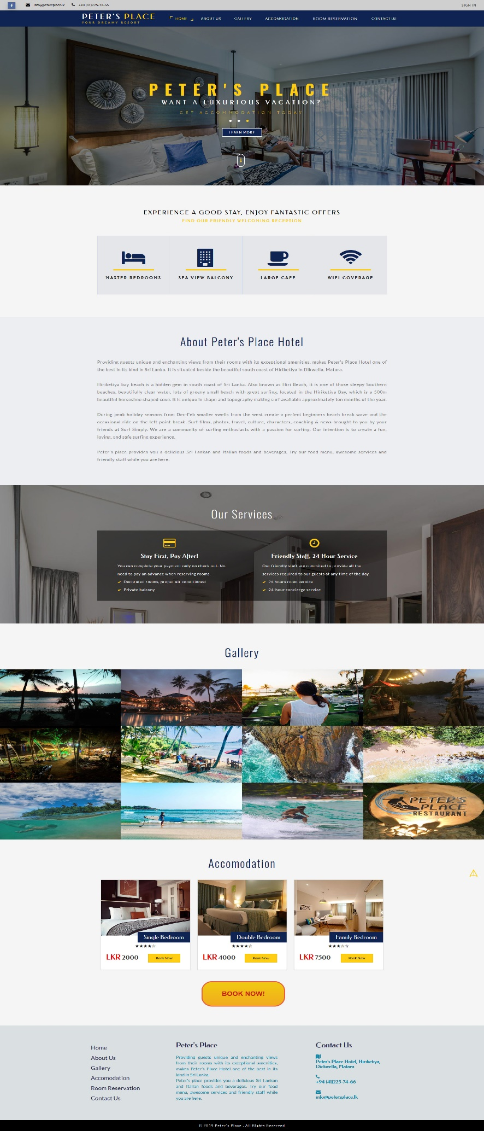

Main Website for   
Peter’s Place Hotel

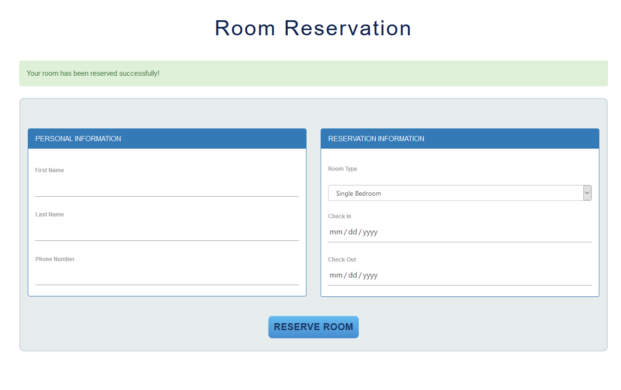

Room Reservation Form

All the forms in this function are properly validated and prevent invalid data being inserted to the database. For example, in this room reservation form,

1. The first name and the second name must only include alphabetic characters.
2. All the fields must be filled (can’t be empty).
3. Phone number must be in a valid format and can’t exceed the character limit.
4. Check in date must be a date from today onwards.
5. Check out date must be a date after the check in date.

If the user enters invalid inputs in any of the forms, meaningful warning error messages are displayed and prompt the user to enter data again. If the data entered are valid and the process is successful, a success message is displayed to the user as a confirmation.

All the validations in the Room Reservation and Room Management function are validated using built in function of the PHP Laravel framework.

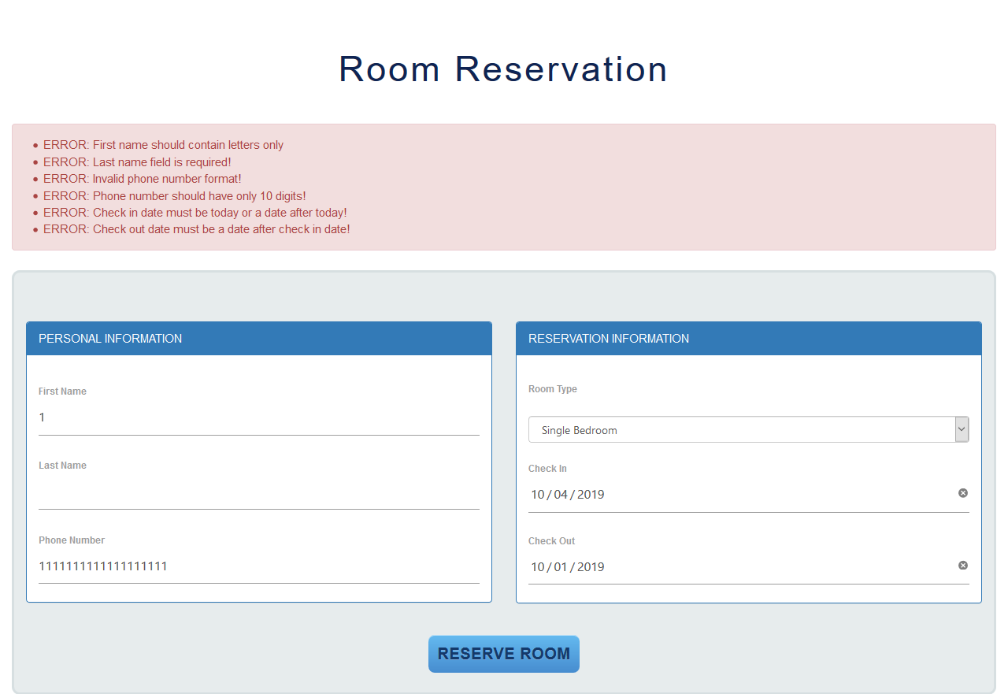

Room Reservation Form Validations

Although until now there is no access controlling to see this part of the web application, the next part of this function (room management function) requires administrator login. The room manager of the Peter’s Place Hotel can login to the system as an administrator by providing a valid username and a valid password.

The Room Management part contains mainly three sections.

1. Hotel Rooms
2. Room Types
3. Room Reservations by Guests / Customers

For all these sections, the administrator can perform CRUD operations and can generate meaningful reports. The operations the administrators can perform for each of the three sections include,

1. Inserting new records
2. Viewing details of an existing record
3. Updating details of an existing record
4. Searching records according to a condition / query
5. Delete a record
6. Generate a meaningful report containing a list of records for each section

Room Management and Reservation function uses mainly four tables in the database.

1. rooms
2. room types
3. reserves
4. customers

For the database MySQL was used and phpMyAdmin was used as the administration tool for MySQL. XAMPP server was used as the web server. Database tables were created using Migrations of the PHP Laravel Framework.

All four used tables for Room Management function were joined using foreign key constraints as required.

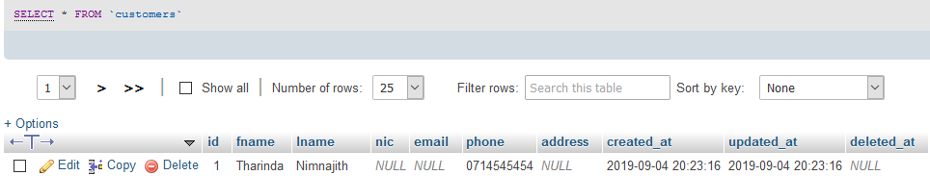

Room Types Table

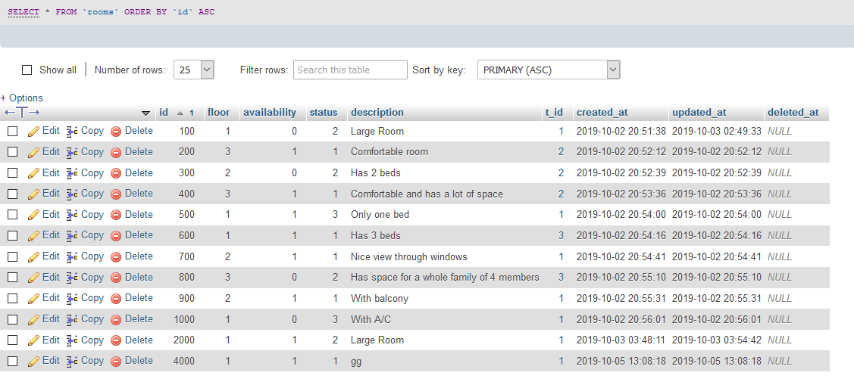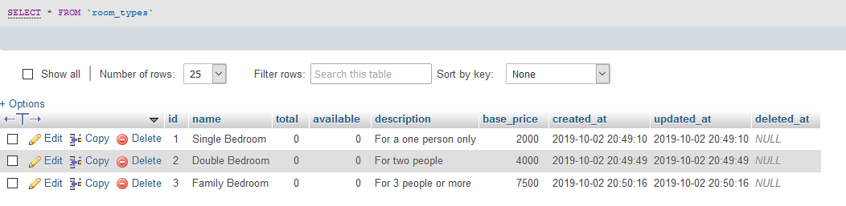

Reserves Table

Customers Table

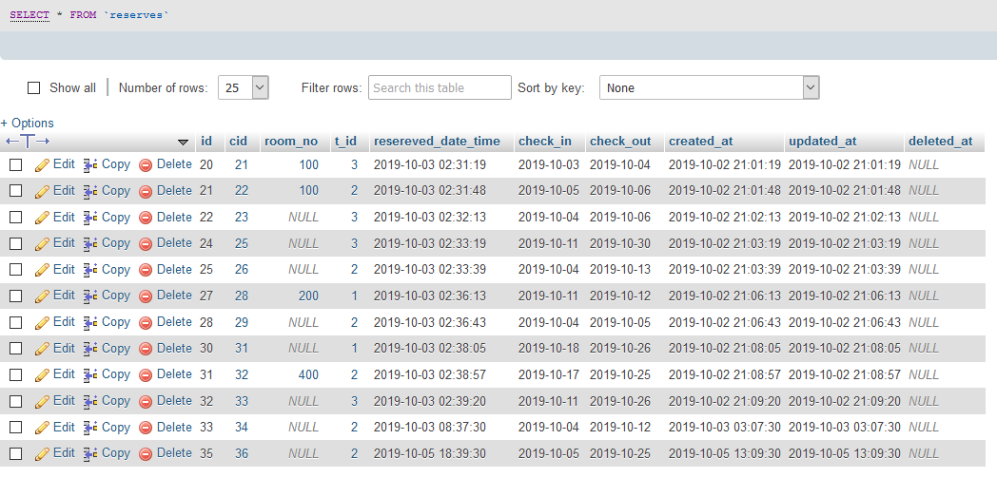

Rooms Table

The administrator can see a list of room reservations made by customers through the official hotel website. The admin can not only see a list of the reservations, but also can view, update and delete individual reservations. Admin can also search reservations from the whole list and get only several records that matches a certain condition/s and generate a report of the reservations list to send it to the front desk manager.

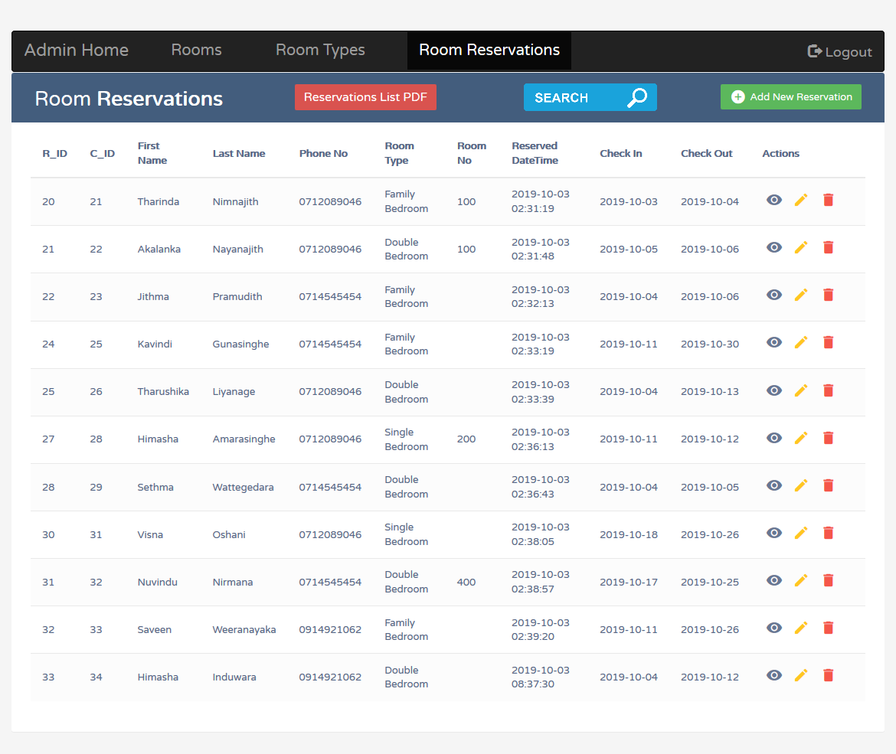

Room Reservations Management

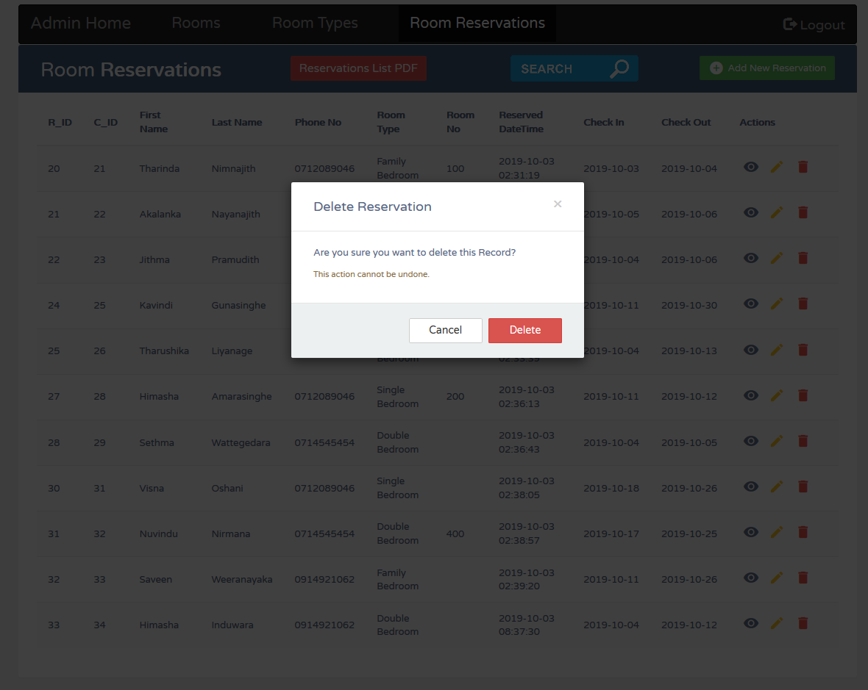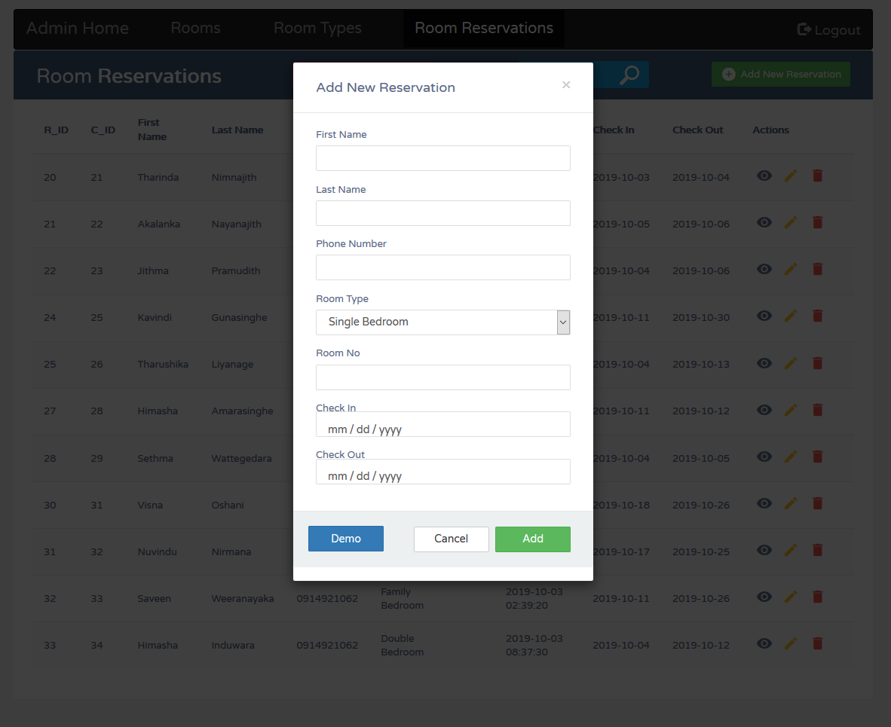

Delete Room Reservation

Add New Room Reservations

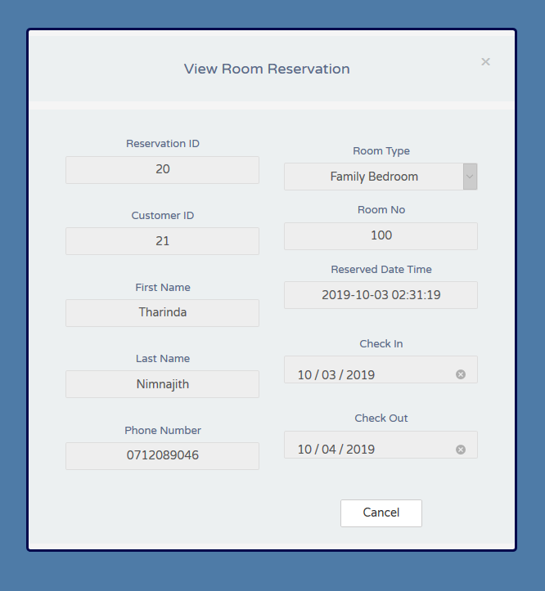

View Room Reservation

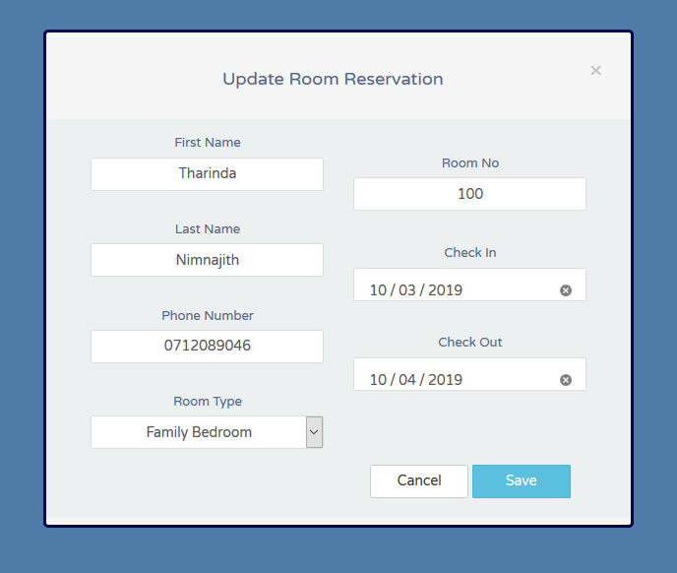

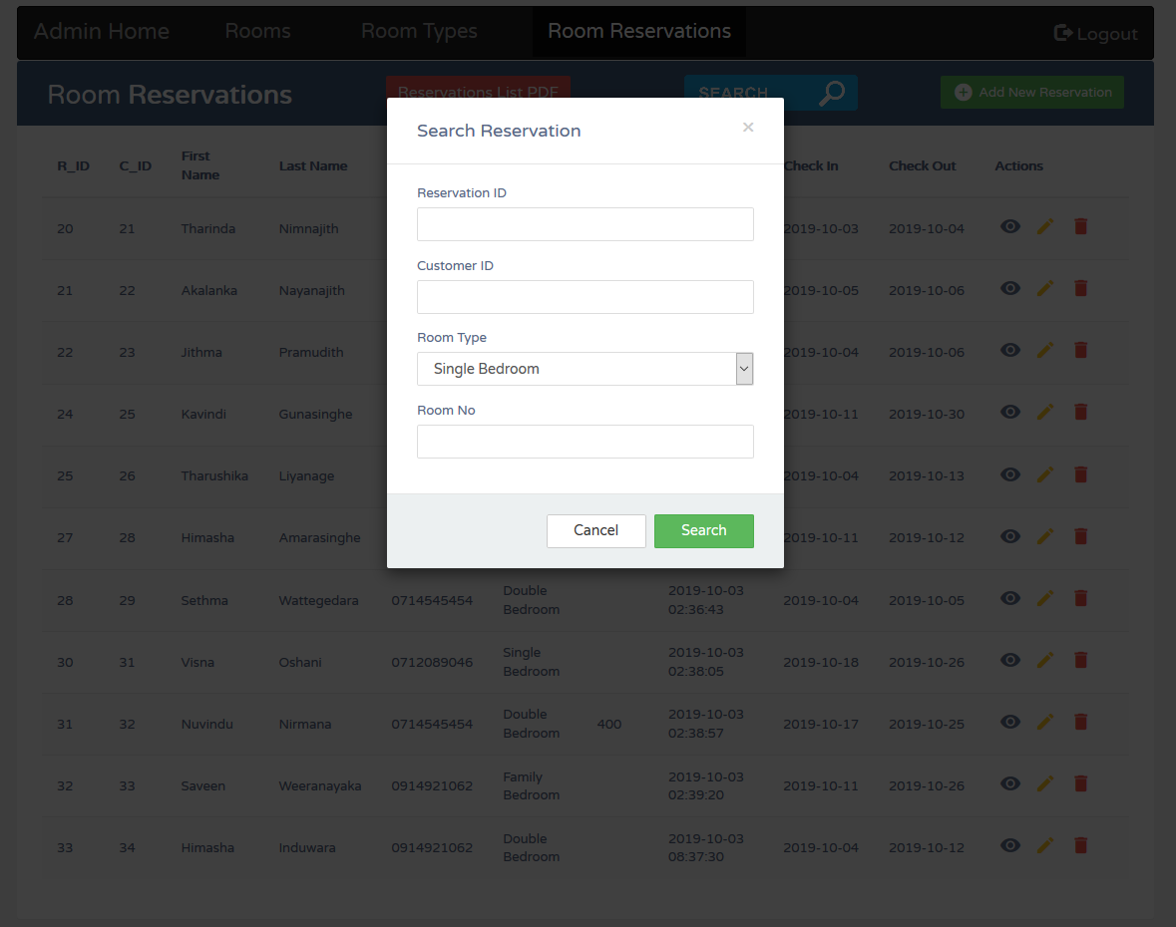

Update Room Reservation

Search Room Reservations

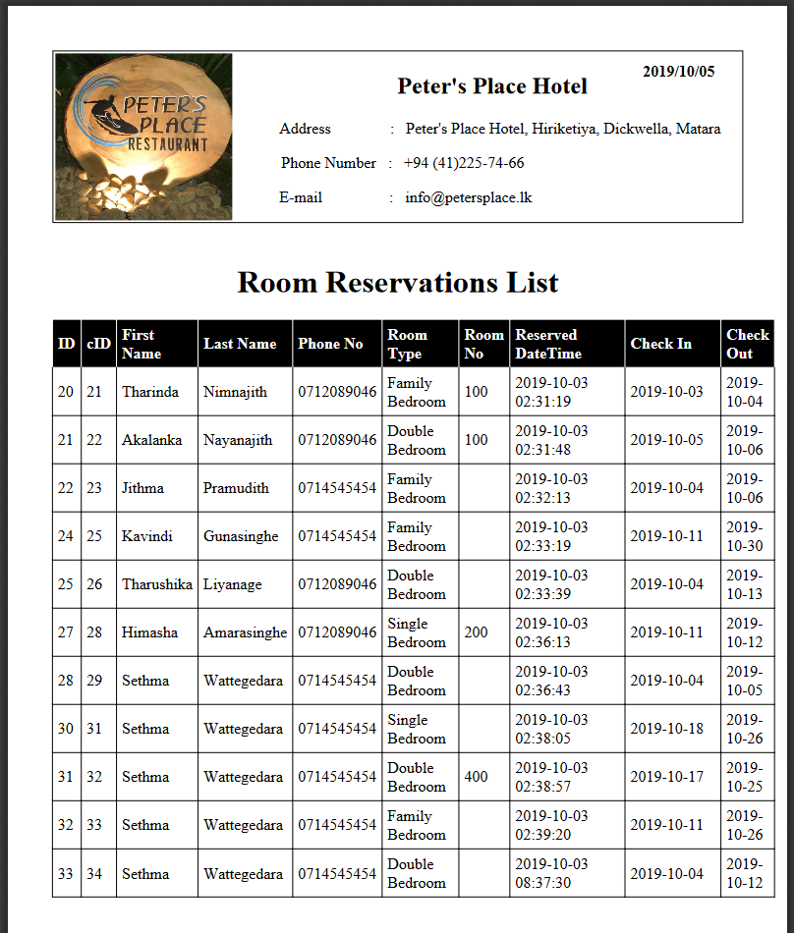

Room Reservations List Report – PDF Generation

PHP Laravel Framework has been used to implement these functionalities and functions are built according to the MVC (Model – View - Controller) architecture. All the methods are implemented in a controller named RoomsController. Model classes are defined separately, and the views are implemented in the blade files separately. The routes are defined in a separate file named web.php.

For the purpose of generating reports, dompdf was used which is an HTML to PDF converter.

All these above functionalities are implemented the same way as the Room Reservations Management section for the Rooms section and Room Types section as well.

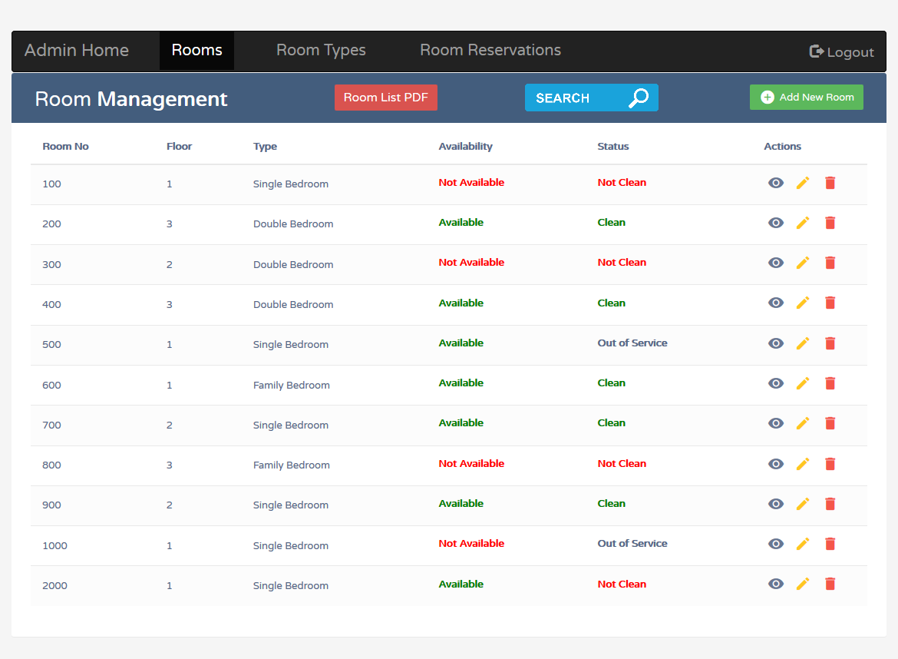

Room Management

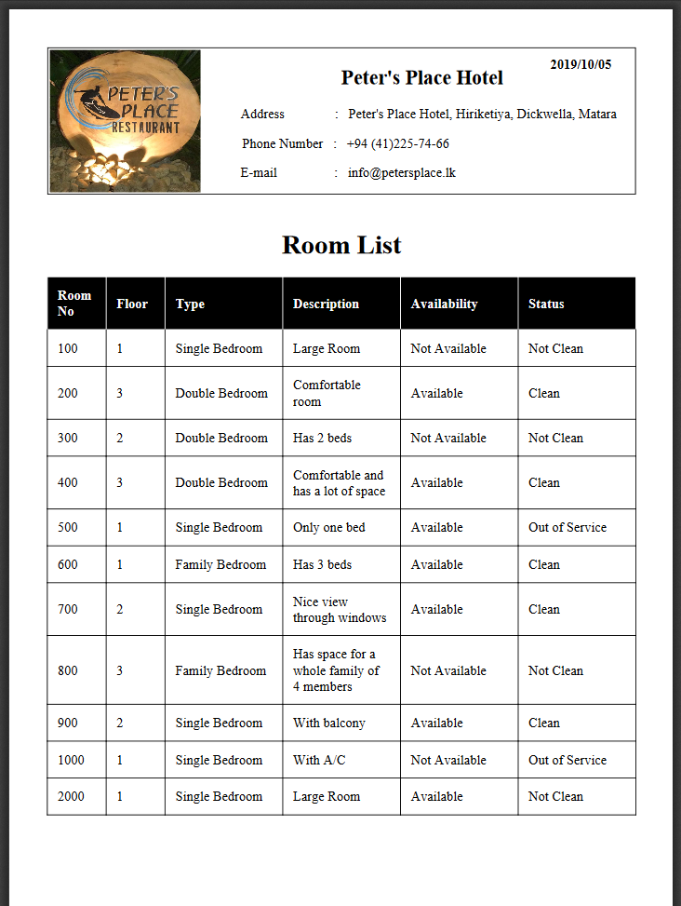

Room List Report – PDF Generation

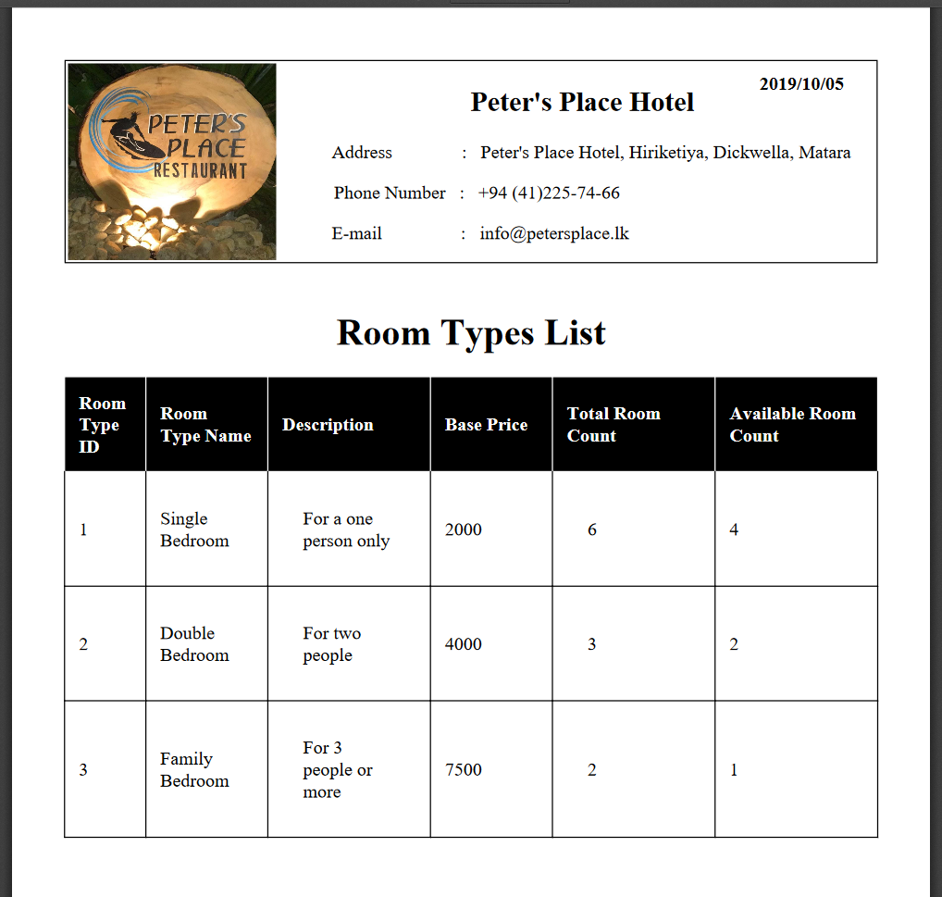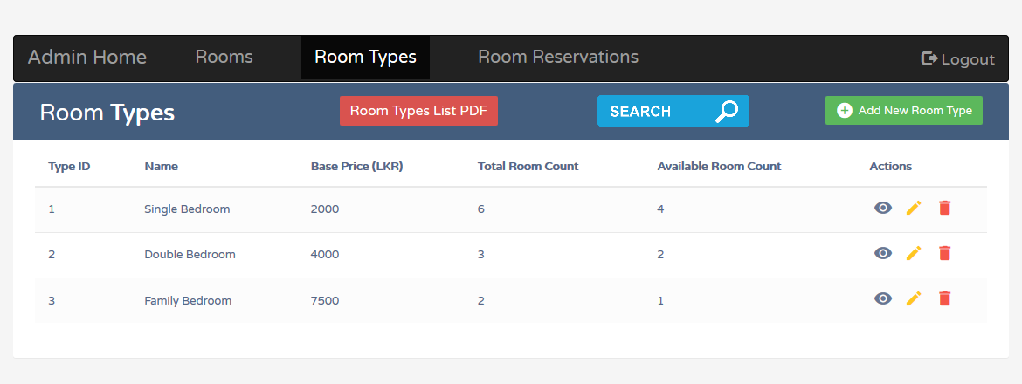

Room Type Management

Room Types List Report – PDF Generation